# 3.7 The Cross Product: Geometry

## THE CROSS PRODUCT OF TWO VECTORS AND THE RIGHT-HAND RULE

The cross product of the two vectors $\vec{u}$ and $\vec{v}$, is itself a vector. Where is this vector $\vec{u}×\vec{v}?$ The cross product of two vectors is a vector perpendicular to the plane formed by the two vectors. What if there are two perpendicular directions? Does this perpendicular vector lie above or below the plane formed by the two vectors? Let’s use the **right-hand rule**.

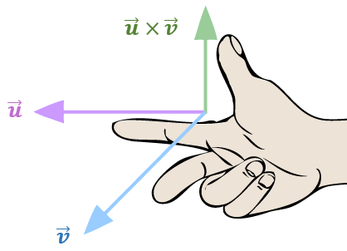

Hold your hand as shown in the picture, your index and middle fingers extended. Your thumb points in the direction of the cross product.

## THE GEOMETRY OF THE CROSS PRODUCT

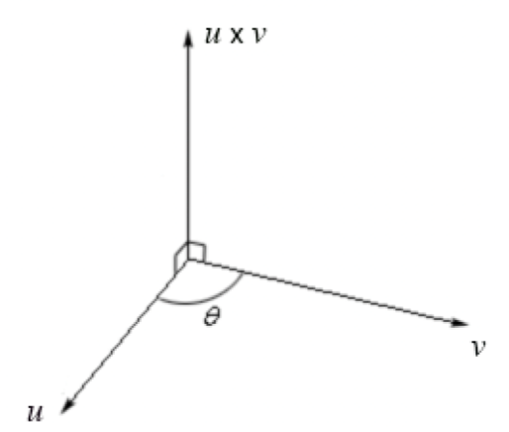

If $θ$ is the angle between the two vectors $\vec{u}=\left\langle u_{x},\left.u_{y}, u_{z}\right\rangle \right.$ and $\vec{v}=\left\langle v_{x},\left.v_{y}, v_{z}\right\rangle \right.$, then the length (magnitude) of the cross product $\vec{u}×\vec{v}$ is

$$\left\|\vec{u}×\vec{v}\right\|= \left\|\vec{u}\right\|\left\|\vec{v}\right\|sinθ$$

$‖\vec{u} ‖=\sqrt{{u_{x}}^{2}+{u_{y}}^{2}+ {u_{z}}^{2}}$ and $‖\vec{v} ‖=\sqrt{{v_{x}}^{2}+{v_{y}}^{2}+ {v_{z}}^{2}}$

The length of the vector $\vec{u}×\vec{v}$, where $\vec{u}=\left\langle 5,\left.2, 4\right\rangle \right.$ and $\vec{v}=\left\langle 3,\left.4, -7\right\rangle \right.$ is

Example (1)

$$\left\|\vec{u}×\vec{v}\right\|= \left\|\vec{u}\right\|\left\|\vec{v}\right\|sinθ$$

$$\sqrt{{u_{x}}^{2}+{u_{y}}^{2}+ {u_{z}}^{2}}∙\sqrt{{v_{x}}^{2}+{v_{y}}^{2}+ {v_{z}}^{2}}∙sinθ$$

We now need to get $sinθ$. We’ll use the formula for the angle between two vectors.

$$θ= \cos^{-1}\frac{\vec{u}∙\vec{v}}{‖\vec{u} ‖∙‖\vec{v} ‖}$$

$$θ= \cos^{-1}\frac{\left\langle 5,\left.2,4\right\rangle \right.∙\left\langle 3,\left.4, -7\right\rangle \right.}{\sqrt{5^{2}+2^{2}+ 4^{2}}∙\sqrt{3^{2}+4^{2}+ {(-7)}^{2}}}$$

$$θ= \cos^{-1}\frac{5∙3+2∙4+4∙(-7)}{\sqrt{45}∙\sqrt{74}}$$

$$θ= \cos^{-1}\frac{-5}{\sqrt{45}∙\sqrt{74}}$$

$$θ= 94.97°$$

Now we compute $\left\|\vec{u}×\vec{v}\right\|=\sqrt{45}∙\sqrt{74}\sin\left(94.97°\right)=57.49$ units.

## USING TECHNOLOGY

We can use technology to find the magnitude of the cross product of two vectors.

Go to www.wolframalpha.com.

To find the length of the cross product of the vectors $\vec{u}=\left\langle 5,\left.2,4\right\rangle \right.$ and $\vec{v}=\left\langle 3,\left.4, -7\right\rangle \right.$ enter magnitude of <5,2,4> cross <3,4,-7>in the entry field.Wolframalpha tells you what it thinks you entered and its answer. In this case it shows you result of $\sqrt{3305}$. Click on the approximate form button to get the result in decimal form as $57.49$.

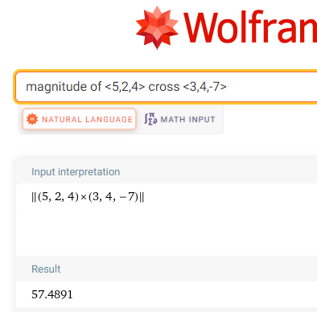

## AREA OF A PARALLELOGRAM

Geometrically, $\left\|\vec{u}×\vec{v}\right\|$ produces the area of a parallelogram determined by $\vec{u}$ and $\vec{v}$.

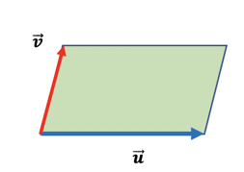

Area = $\left\|\vec{u}×\vec{v}\right\|= \left\|\vec{u}\right\|\left\|\vec{v}\right\|sin θ$

For example, the area of the parallelogram determined by the vectors $\vec{u}=\left\langle 5,\left.2, 4\right\rangle \right.$ and $\vec{v}=\left\langle 3,\left.4, -7\right\rangle \right.$ 
 is 57.49 square units.

## THE CROSS PRODUCT OF PERPENDICULAR AND PARALLEL VECTORS

If vectors $\vec{u}$ and $\vec{v}$ are *perpendicular* to each other, then the angle between them is 90° and $\sin\left(90°\right)=1$, so that

$$\vec{u}×\vec{v}= \left\|\vec{u}\right\|\left\|\vec{v}\right\|$$

If vectors $\vec{u}$ and $\vec{v}$ are *parallel* to each other, then the angle between them is 0° and $\sin\left(0°\right)=0.$

It makes sense then to define the cross product of parallel vectors to be the zero vector, $\vec{0}$. Also, if at least one of the vectors $\vec{u}$ and $\vec{v}$ is the zero vector, $\vec{0,}$ then the cross product $\vec{u}×\vec{v}$ is defined to be the zero vector. We can say that if the cross product of two vectors is zero, then the vectors are parallel to each other. Also, if two vectors are parallel to each other, then their cross product is zero. We combine these statements together in an *if-and-only-if* statement.

Nonzero vectors $\vec{u}$ and $\vec{v}$ are parallel to each other if and only if $\vec{u}×\vec{v}= 0$.

**PROPERTIES OF THE CROSS PRODUCT**

1. $\vec{u}×\vec{v}=-\vec{v}×\vec{u}$, the cross product is **anti-commutative**
2. $k\left(\vec{u}×\vec{v}\right)=k\vec{u}×\vec{v}= \vec{u}×k\vec{v}$, multiplication by a scalar
3. $\vec{u}×\left(\vec{v}+\vec{w}\right)=\vec{u}×\vec{v}+\vec{u}×\vec{w}$, the cross product distributes over vector addition
4. $\vec{u}×\vec{0}=0$, the cross product with the zero vector, $\vec{0},$ zero vector, $\vec{0}$.

Use WolframAlpha to verify that

Example (2)

$$\vec{u}×\left(\vec{v}+\vec{w}\right)=\vec{u}×\vec{v}+\vec{u}×\vec{w}$$

where $\vec{u}=\left\langle 5,\left.-2, -3\right\rangle \right.$, $\vec{v}=\left\langle 6,\left.4, 1\right\rangle \right.$, and $\vec{w}=\left\langle -3,\left.7, 2\right\rangle \right.$.

Use W|A to first compute $\vec{u}×\left(\vec{v}+\vec{w}\right)=\vec{u}$ and then $\vec{u}×\vec{v}+\vec{u}×\vec{w}$. Determine if the results do or do not match. We can do this in one step by entering

<5,-2,-3> x (<6,4,1> + <-3,7,2>) = <5,-2,-3> x <6,4,1> + <5,-2,-3> x <-3,7,2>

If the statement on the left of the = equals the statement on the right, W|A responds with True.

If the statement on the left of the ≠ equals the statement on the right, W|A responds with False.

In this case, we get a True response and have verified the truth of the statement.

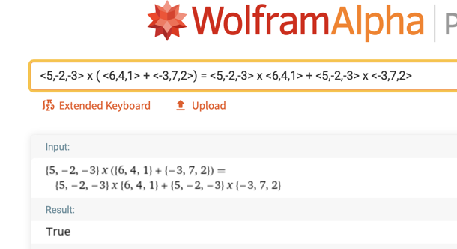

## EXAMPLES

1. Find the cross product of the vectors $\vec{u}=\left.⟨-4, 3, 5\right\rangle$ and $\vec{v}=\left\langle 5,\left.-1, 2\right\rangle \right.$.

ANS: $\vec{u}×\vec{v}= \left\langle 11,\left.33,-11\right\rangle \right.$

1. Find the cross product of the vectors $\vec{u}=\left.⟨-2, 3,-9\right\rangle$ and $\vec{v}=\left\langle 6,\left.-9, 27\right\rangle \right.$.

ANS: $\vec{u}×\vec{v}=\left.⟨0, 0, 0\right\rangle$ **= $\vec{0}$**

1. Find the length of the vector formed by the cross product of the of the vectors $\vec{u}=\left.⟨3, -5, 4\right\rangle$ 
    and $\vec{v}=\left\langle 2,\left.-4, 1\right\rangle \right.$.

ANS: $5\sqrt{6}$ = 12.2 units

1. Find the angle between the vectors $\vec{u}=\left.⟨4, -7,-6\right\rangle$ and $\vec{v}=\left\langle 5,\left.-1, 2\right\rangle \right.$.

ANS: $θ= \cos^{-1}\frac{\vec{u}∙\vec{v}}{‖\vec{u} ‖∙‖\vec{v} ‖}$

$θ= \cos^{-1}\frac{\left\langle 4,\left.-7,6\right\rangle \right.∙\left\langle 5,\left.-1, 2\right\rangle \right.}{\sqrt{4^{2}+{(-7)}^{2}+ 6^{2}}∙\sqrt{5^{2}+{(-1)}^{2}+ 2^{2}}}$

$θ= \cos^{-1}\frac{4∙5+(-7)∙(-1)+6∙2}{\sqrt{91}∙\sqrt{30}}$

$θ= \cos^{-1}\frac{25}{\sqrt{101}∙\sqrt{30}}$

$θ= 74.19°$

1. Determine if the vectors $\vec{u}=\left.⟨3, -2, 1\right\rangle$ and $\vec{v}=\left\langle 0,\left.2, 4\right\rangle \right.$ are perpendicular or parallel to each other.

ANS: Perpendicular since $\vec{u}∙\vec{v}=0$

1. Find the area of the parallelogram and the triangle formed by the vectors

$\vec{u}=\left.⟨1, -2,-4\right\rangle$ and $\vec{v}=\left\langle 4,\left.3, -5\right\rangle \right.$.

ANS: Parallelogram is $26.94$ square units,  
 Triangle is (½ of $26.94)$ = $13.47$ square units

## NOTE TO INSTRUCTOR

Consider as examples:

1. Find the cross product of the vectors $\vec{u}=\left.⟨2, 3, -4\right\rangle$ and $\vec{v}=\left\langle 5,\left.5, 3\right\rangle \right.$.

ANS: $\vec{u}×\vec{v}= \left.⟨29, -26, -5\right\rangle$

1. Find the cross product of the vectors $\vec{u}=\left.⟨-4,-2, 4\right\rangle$ and $\vec{v}=\left\langle 8,\left.4, -8\right\rangle \right.$.

ANS: $\vec{u}×\vec{v}=\left.⟨0, 0, 0\right\rangle = \vec{0}$

1. Find the length of the vector $\vec{v}=3\left.⟨5, -1, 3\right\rangle -2\left.⟨2, -3, 1\right\rangle$.

ANS: $\sqrt{17}$

1. Find the angle between the vectors $\vec{u}=\left.⟨2, -6, 3\right\rangle$ and $\vec{v}=\left\langle \left.-3, 10, 2\right\rangle \right.$.

ANS: $θ= \cos^{-1}\frac{\vec{u}∙\vec{v}}{‖\vec{u} ‖∙‖\vec{v} ‖}$

$θ= \cos^{-1}\frac{\left.⟨2, -6, 3\right\rangle ∙\left\langle -3,\left.10, 2\right\rangle \right.}{\sqrt{2^{2}+{(-6)}^{2}+ 3^{2}}∙\sqrt{{(-3)}^{2}+{(10)}^{2}+ 2^{2}}}$

$θ= \cos^{-1}\frac{2∙(-3)+(-6)∙(10)+3∙2}{\sqrt{49}∙\sqrt{113}}$

$θ= \cos^{-1}\frac{-60}{\sqrt{49}∙\sqrt{113}}$

$θ= 143.74°$

1. Find the angle between the vectors $\vec{u}=\left.⟨-3, -2, 5\right\rangle$ and $\vec{v}=\left\langle 6,\left.4, 10\right\rangle \right.$.

ANS:

[3-7_the_cross_product_geometry.docx](https://oer4cte.org/math4gamedevelopers/teacher/3-7_the_cross_product_geometry.docx), attributed to Denny Burzynski (author) and Downey Unified School District (publisher) is licensed under CC BY-NC 4.0. To view a copy of this license, visit https://creativecommons.org/licenses/by-nc/4.0